How technology can be used to help university students manage their time effectively

Alarna Oyaide 2020 (N0931110)

Project report in part fulfilment  
of the requirements for the degree of  
Bachelor of Science with Honours  
In  
Computer Science

2022

**NOTTINGHAM TRENT UNIVERSITY**

**SCHOOL OF SCIENCE AND TECHNOLOGY**

# Declarations

I hereby declare that I am the sole author of this report. I authorize the  
Nottingham Trent University to lend this report to other institutions or  
individuals for the purpose of scholarly research.

I also authorize the Nottingham Trent University to reproduce this report by  
photocopying or by other means, in total or in part, at the request of other  
institutions or individuals for the purpose of scholarly research.

  
Alarna Oyaide

# Abstract

This project explores the role of technology in enhancing time management skills of university students through the development of a student planner application. The aim of this research is to investigate the challenges students face in managing their time and to identify the key features that would make a useful student planner. The findings indicate that a student planner application can be an effective tool for time management, particularly if it includes features such as time management tools, scheduling, and notifications. The research concludes with recommendations for the design and development of a student planner application that meets the needs of university students and can improve their academic performance.

Contents

Declarations 1

Abstract 2

**Introduction** 5

University and Health 5

The Importance of Time Management 6

Problem Statement 6

Aims and Objectives 7

Aim: 7

Objectives: 7

**Context** 7

Literature Review 7

The Importance of Time Management for University Students: 7

Time Management Aiding Factors 8

Effective Time Management Strategies for University Students 8

The Role of Technology in Time Management: 9

Conclusion: 15

**New Ideas** 15

Introduction 15

Overview of current Challenges 16

Procrastination 16

Balancing work and study 16

Avoiding distractions 17

Conclusions 17

Innovative Solutions 17

Advantages and Limitations 18

User Interface Design 19

**Implementation** 20

Technical Specification for UniLife 20

Overview 20

Features 20

What to Avoid 21

Technical Skills Requirements 21

Resources 21

Special Techniques 21

Costing 21

Diagrams 22

Tools and Techniques 22

Planning 22

Mitigation Plan 23

Unit Testing 24

**Results** 26

Success Criteria 26

Technique 27

Testing: 27

Testing Plan for Future Developments 27

Analysis 28

**Appendix** 29

Gantt Chart 29

Testing Images 30

**References** 31

Table of Figures

Figure 1 – Trello App User Interface (IOS) 10

[Figure 2 – Evernote App User Interface (IOS) 11](https://myntuac-my.sharepoint.com/personal/n0931110_my_ntu_ac_uk/Documents/Year%203/FYP/REPORT.docx#_Toc132967192)

[Figure 3 – Google Calendar User Interface (IOS) 12](https://myntuac-my.sharepoint.com/personal/n0931110_my_ntu_ac_uk/Documents/Year%203/FYP/REPORT.docx#_Toc132967193)

[Figure 4 – Focus Keeper User Interface (IOS) 13](https://myntuac-my.sharepoint.com/personal/n0931110_my_ntu_ac_uk/Documents/Year%203/FYP/REPORT.docx#_Toc132967194)

Figure 5 – Simple UI design for UniLife App 19

[Figure 6 – Gantt Chart for Report and App Development 30](https://myntuac-my.sharepoint.com/personal/n0931110_my_ntu_ac_uk/Documents/Year%203/FYP/REPORT.docx#_Toc132967196)

Figure 7 – Test 01 31

Figure 8 – Test 02 31

Figure 9 – Test 03 31

Figure 10 - Test 04 31

Figure 11 - Test 06 31

Figure 12 - Test 07 31

Figure 13 - Test 07 31

Figure 14 - Test 08 31

Figure 15 - Test 09 31

Figure 16 – Test 10 31

Figure 17 - Test 11 31

Figure 18 - Test 13 31

Figure 19 - Test 14 31

Figure 20 - Test 15 - 18 32

# **Introduction**

Going to university tends to be one of the most popular pathways for school leavers out of college/sixth form. Alongside further education in a specific subject of study, students are often presented with new challenges such as living alone/ independently for the first time, catapulting them into adult life. Balancing relationships, friendships, free time, hobbies etc. all whilst managing assignments and university workload can be become quite daunting for the average student and not just traditional- entry students (Trueman and Hartley, 1996) but for mature students as well. Mature students tend to deal with varying difficulties to traditional- entry students; most pressuring being financial, family responsibilities and pressure of time (Cleugh, M. F. 1972). Although students of different ages may experience slightly different challenges, they all can result in the same increase of levels of stress for the individual.

### University and Health

Health is a vital aspect of a university student's life, as it plays a significant role in their overall academic performance and quality of life. University students (mature and traditional entry) are often faced with new challenges, such as adapting to a new environment, managing a busy schedule, and coping with academic pressures, which can have a significant impact on their mental, physical and emotional well-being.

One of the most significant mental health challenges facing university students is stress. The expectations of academic success can be overwhelming, with deadlines, exams, and essays looming over students. As previously mentioned before, many students are living independently for the first time, and this can come with a range of financial and personal stressors. With these additional factors, the increase in stress can result in mental health issues such as anxiety, depression, panic attacks and decreased self-esteem which can be a catalyst for physical health problems such as nausea, eating problems and insomnia (International Journal of School & Educational Psychology, 2016). Moreover, these problems can become emotional issues which can manifest in a variety of ways, such as social isolation, difficulties in maintaining relationships, and decreased motivation to engage in activities that students once enjoyed. As a result, stress can become a constant presence in a student’s life, leading to negative effects on their mental health (Pozos-Radillo et al., 2014).

As well as affecting your mental health, chronic stress can affect your physical health (Toussaint, 2016). Generally, chronic stress has been linked to a range of issues, including high blood pressure, heart disease, and digestive problems. More specifically in students, chronic stress can result in fatigue, lack of energy and decreased motivation to engage in physical activity which can further exacerbate physical health problems (Gianaros, 2015). Subsequently, this can lead to absenteeism from classes and result in missed coursework, which can impact a student's academic performance and future career prospects.

Consequently, an increase of stress on an individual can result in a decrease in the persons overall Quality of Life. Quality of Life (QoL) is defined as an individual’s perception of their position in life in the context of culture and value system where they are inserted, which also involves their goals, perspectives, standards, and concerns (Ribeiro et al., 2018). ). As chronic stress inhibits a person’s ability to reach their goals, this means that this would negatively impact a person’s QOL. Knowing all of this, begs the question of **how can students manage a high QoL in the face of managing multiple responsibilities?**

### The Importance of Time Management

*“In schoolwork, it is essential to have a plan of action. If you budget your day and then adhere to this program, you can eliminate half the effort and worry from your work. A plan that is steadily followed soon becomes the easy and natural routine of the day.” (Kornhauser 1993)*

Time management is a critical process for students that involves organizing and allocating time for various activities, and it is integral to achieving success and maintaining a good quality of life. Proper time management brings several positive outcomes, including increased productivity, expanded opportunities to achieve personal goals, reduced stress, and ultimately, an improved quality of life. This approach acts as a catalyst for better mental and physical health by allowing individuals to have ample time for leisure activities, which helps eliminate the stress of unmanaged tasks hovering in the back of their minds.

To effectively and efficiently manage their time, students need to consider three key factors: ‘what to study, how long to study, and how to study with instructors’ minimal intervention.’ (Ahmad Uzir et al., 2019). For instance, one strategy a student could use would be to access learning materials ahead of time and take notes during lectures to further their understanding of the topics being covered, which can subsequently aid in future assessments. Presently, we are fortunate to have access to the internet and advanced technology. We rely on numerous resources on a daily basis, including embedded systems in hardware and software in mobile phone applications, to simplify our lives. Among these resources are tools for education and time management, such as daily planners and educational materials, which assist students in organizing their studies.

This project aims to explore how technology can be used to improve time management skills in university students by objectively creating an application that merges study and life tools thus eliminating the boundaries between them. Specifically, it will examine the effectiveness of various time management applications and software tools in facilitating better time management practices among university students. By analysing the impact of technology on time management, this study aims to provide valuable insights into how students can use technology to optimize their time and achieve better academic and personal outcomes.

## Problem Statement

University students face numerous challenges, including adapting to a new environment, managing a busy schedule, and coping with academic pressures, which can negatively impact their mental, physical, and emotional well-being. Stress is a significant mental health challenge faced by university students, which can lead to anxiety, depression, and other physical and emotional problems. Chronic stress can also lead to absenteeism from classes and missed coursework, which can impact a student's academic performance and future career prospects. Therefore, it is crucial to explore how technology can be used to improve time management skills among university students and ultimately optimize their time and achieve better academic and personal outcomes. This study aims to investigate the effectiveness of various time management applications and software tools in facilitating better time management practices among university students, leading to improved academic performance and overall quality of life.

## Aims and Objectives

Aim: To explore how technology can be used to improve time management skills in university students.

### Objectives:

* To investigate the impact of time management on the quality of life of university students.
* To examine the effectiveness of various time management applications and software tools in facilitating better time management practices among university students.
* To identify the key factors involved in effective time management for university students.
* To create a prototype solution of an app to help students with their time management.
* To provide recommendations for university students on how to optimize their time management skills using technology.
* To evaluate the potential impact of improved time management skills on academic performance and personal outcomes for university students.

# **Context**

## Literature Review

Effective time management is crucial for university students to succeed academically and balance their personal lives. Technology has become an integral part of students' daily lives, and it can play a significant role in helping students manage their time effectively. This literature review examines the various ways in which technology can be used to assist university students in managing their time.

### The Importance of Time Management for University Students:

University students often face a multitude of tasks that require effective time management skills. These tasks include attending lectures, completing assignments, studying for exams, participating in extracurricular activities, and balancing personal commitments. With so many responsibilities to juggle, it's easy for students to feel overwhelmed and stressed. Research by Macan et al. (1990) has shown that the failure to manage time efficiently can lead to poor academic performance and increased stress levels. Inadequate time management can also lead to a decreased quality of life outside of academic pursuits. In addition to academic responsibilities, students may have to balance part-time jobs, family obligations, and social commitments. Without effective time management skills, it can be challenging to balance all these commitments, leading to decreased productivity and increased stress levels.

Moreover, different researchers have investigated for years the importance of effective time management skills and students. Race (2003) discovered that possessing effective time management skills is crucial in preventing issues that may hinder a student's academic success. Furthermore, according to Roper (2007), the capability to formulate time management tactics is the primary requirement for achieving lifelong learning. Stewart, Barbara L; Miertschin, Susan; Goodson, Carole investigated the importance of managing time but also balancing key lifestyle variables (student employment, student participation in campus organisations and student perception of anxiety regarding spending time with family and friends) as these were found to be the most important variables that students engage in to aid in increased student success (COVID-19 Transitions to Online Formats and Pre-Pandemic Foundations for Student Success: Time Management and Lifestyle Variables - ProQuest, 2020). They found that educators should consider these lifestyle variables when designing courses, and students should consider their lifestyle decisions to apply time management skills for academic and career success. Students can seek input from counsellors, mentors, and publications to improve time management skills and balance academics with other pursuits.

### Time Management Aiding Factors

Although time management is crucial to a student’s success other factors can/may aid this even more. By designing a solution that can assist to other aspects for successful learning, this can further optimise the student’s overall success and potentially make learning easier.

It is important to know that a student’s success can be increased depending on the learning style that the student responds best to. The different learning styles include visual learners, auditory learners, read-write learners, and kinaesthetic learners (Sayles and Shelton, 2005). Visual learners are individuals who learn best through visual aids such as diagrams, images, videos, or graphs. They process information best when they can see it in front of them. These learners prefer to read information rather than listen to it. They learn best by taking notes, making diagrams or mind maps, and observing the world around them. Secondly, auditory learners are individuals who learn best through hearing and listening. They process information best when it is presented to them through sound. They prefer to listen to lectures, audio books, and discussions rather than reading material. Thirdly, Read-write learners are individuals who prefer to learn through reading and writing activities. They have a strong affinity for words, both written and spoken, and excel in activities that involve reading and writing. Read-write learners prefer to read and take notes to learn new information. They often excel at written assignments, including essays, research papers, and other written assignments that require critical thinking and analysis. Finally, Kinaesthetic learners are individuals who learn best through movement and physical activity. They process information best when they can physically interact with the material or environment. They prefer to learn through physical activities, such as role-playing, building, or experimenting with objects. Although these learning styles are quite different, most students will use multiple learning styles to learn, most popular being auditory and read-write learning styles (Kharb, 2013). If students can identify their learning style, then students can utilize suitable learning strategies to enhance their academic abilities and encourage self-directed learning, hence unlocking their full potential and paving the way for lifelong learning. Therefore, it will be crucial to take into mind different learning styles when developing a solution.

## Effective Time Management Strategies for University Students

A great way to help students manage their time is by setting personal realistic goals and deadlines. Research conducted by (Morisano et al., 2010) explore the method of students setting their own deadlines to do work and complete studying within their larger more important deadlines. They found that students that set goals displayed significant improvements in their overall academic performance compared to students that didn’t. This can be done by breaking larger tasks into smaller, more manageable pieces and setting specific deadlines to stay on track and avoid procrastination. This approach ensures that students have a clear understanding of what needs to be accomplished and by when.

A second strategy is creating a schedule. An article from (Downing, Peckham Hardin 2001) discusses the benefits of schedules and planners; they help individuals including those with disabilities, to organise their day and remember important events. For students, using a planner or calendar to schedule time for studying and completing assignments is an effective way to manage time. Students should allocate sufficient time for each task and stick to the schedule as much as possible. This approach helps students stay organized and avoid last-minute cramming.

Thirdly, another way to help students manage their time is to eliminate distractions. As of present times, researchers (Attia et al., 2017) found that students are becoming more distracted due to various forms of technology and as a result has negative impacts on their concentration and learning. As a solution they found that turning off notifications on their phones, closing unnecessary tabs on their computers, and finding a quiet place to study can help students stay focused and minimize interruptions. Therefore, this allows students to concentrate on their work without being distracted by external factors.

As well as practical solutions, psychological intervention can improve students overall academic performance. One method in doing this is by using positive self-talk. A study conducted by (Sánchez, Carvajal and Saggiomo, 2015) found that training in appropriate self-talk could improve students’ performance in difficult academic situations. On the contrary, they found that negative self-talk was correlated with negative academic performance. Therefore, encouraging themselves with positive affirmations, such as "I can do this" or "I am capable of completing this task," can help students stay motivated and overcome self-doubt. This can help students build confidence and develop a positive attitude towards their work.

To conclude, effective time management is crucial for university students to achieve their academic goals while maintaining a healthy work-life balance. The strategies presented in this paper, including setting realistic goals and deadlines, creating a schedule, eliminating distractions, starting with the most difficult task, using positive self-talk and seeking support, can help students manage their time more effectively and improve their academic performance. By implementing these strategies, university students can develop effective time management skills that will benefit them throughout their academic and professional careers.

### The Role of Technology in Time Management:

Technology has indeed transformed the way in which individuals manage their time (Disselkamp, 2012), and university students are no exception. With the advancements in technology, students have access to various tools and applications that can significantly improve their time management skills. These tools have become a crucial component of the student's academic and personal life, helping them stay organized, focused, and productive. The following are some of the ways in which technology can be used to help university students manage their time effectively.

#### Time Management Applications: Trello

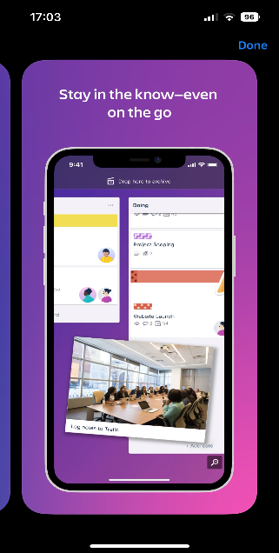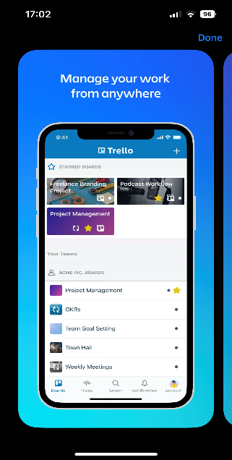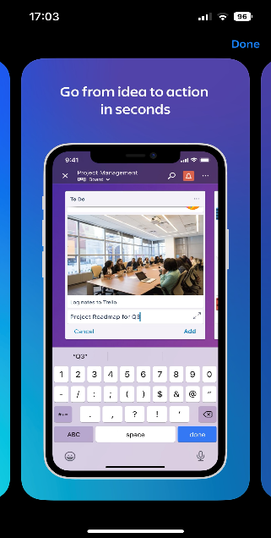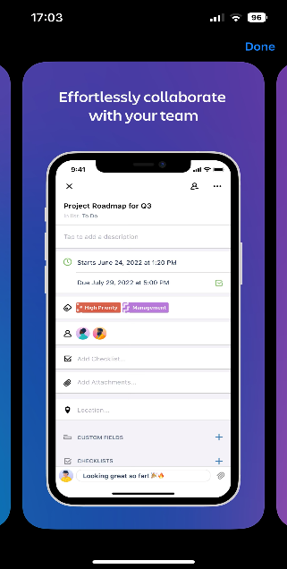

Figure – Trello App User Interface (IOS)

Trello is a web-based project management and collaboration tool that allows users to organize and prioritize their tasks and projects. It uses a system of boards, lists, and cards to help users visualize their work and track progress. (Johnson, MLIS, 2017) Trello has gained popularity among individuals and teams seeking a simple and intuitive way to manage their projects.

Several studies have examined the effectiveness of Trello in enhancing productivity and collaboration. A study by Journal of Hospital Librarianship (2018) found that Trello can improve communication, coordination, and collaboration among team members. The software was also found to be effective in improving the organization and management of tasks for individuals. The study concluded that Trello's visual interface and customization options allowed individuals to tailor their task management to their unique needs and preferences and that Trello's ease of use and visual interface helped team members stay organized and focused on their tasks.

Trello has also been found to be effective in enhancing academic productivity. In a newsletter article (Trello: The best app to have higher productivity in Home Office - ProQuest, 2021) it was also found that Trello can helps users manage their academic tasks and reduce procrastination and The app is free, making it an accessible option for individuals and companies to improve work efficiency. The study concluded that Trello's visual interface and task categorization features helped users prioritize their tasks and stay focused on their academic goals.

Overall, the literature suggests that Trello can be an effective tool for enhancing productivity, collaboration, and task management in various settings. Its visual interface, customization options, and versatility make it a popular choice among individuals and teams seeking a simple and intuitive way to manage their projects. It is also perfect for students as it is a free tool therefore allowing anyone with a compatible device accessibility.

#### Time Management Applications: Evernote

Figure 2 – Evernote App User Interface (IOS)

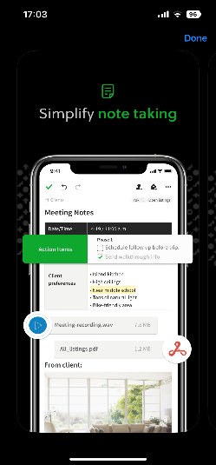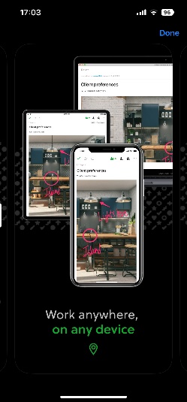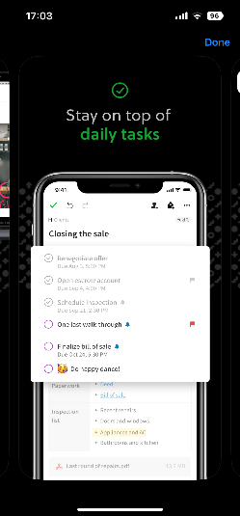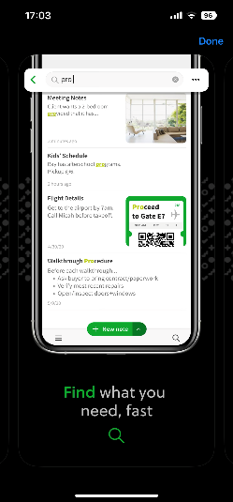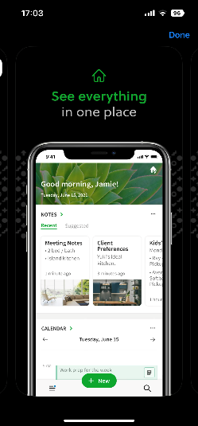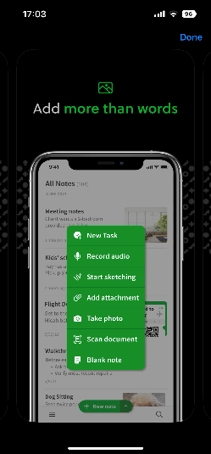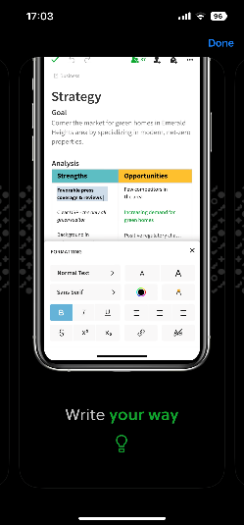

Evernote is a popular note-taking and productivity application that has gained widespread popularity among individuals, students, and businesses. The web service was first launched in 2008 and has since become a go-to tool for organizing and managing information (Hine, 2014). This section of the literature review examines the features and benefits of the Evernote app and its impact on productivity.

One of the primary features of Evernote is its ability to create notes in a variety of formats, including text, audio, and images. This versatility allows users to capture and organize information in a way that suits their individual needs. The app also allows users to add tags, notebooks, and reminders to notes for better organization and retrieval. Additionally, Evernote also offers a web clipper feature that allows users to save web pages and articles for future reference. This feature enables users to collect and organize information from the internet without cluttering their browser bookmarks. The app also has a powerful search function that allows users to quickly find notes and web clippings.

Evernote's collaboration features are also noteworthy, as they allow users to share notes and work collaboratively on projects. This feature is particularly useful for businesses and teams who need to work together on projects remotely. Furthermore, the app has integrations with other popular productivity tools such as Google Drive, Google Keep, Slack, and Microsoft Teams. These integrations allow users to seamlessly move between different productivity apps and workflows without losing productivity.

Evernote has also created features that specifically target students. These features include, being able to organise their class notes into notebooks, scan and search handwritten notes, record lectures and talks, draw and write on PDFs, manage assignments with to do lists and reminders, and keep campus even and student life info in one place (Evernote Help & Learning, 2018). All these features can be incredibly helpful for students looking to improve their organization, productivity, and efficiency in school.

In short, Evernote is a powerful and versatile tool for notetaking, organization, and productivity. Its ability to capture and organize information in a variety of formats, collaborate on projects, and integrate with other productivity tools makes it a valuable asset for individuals, students, and businesses.

#### Electronic Calendars: Google Calendar

Figure 3 – Google Calendar User Interface (IOS)

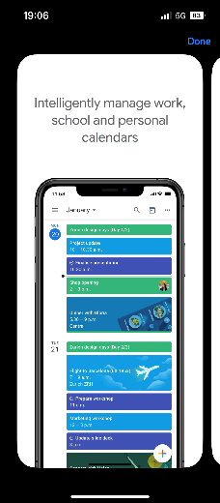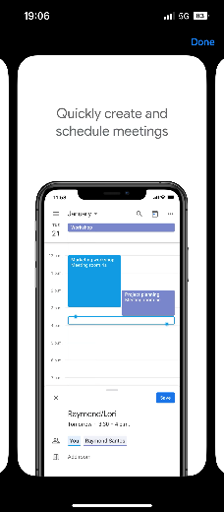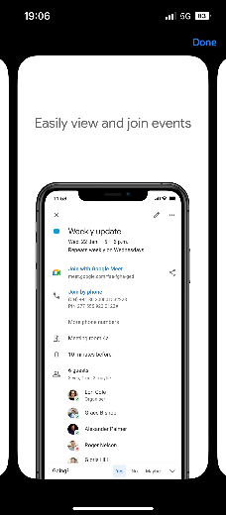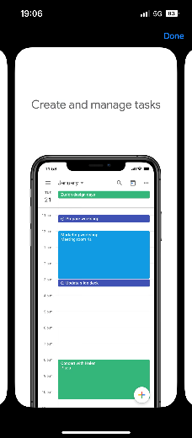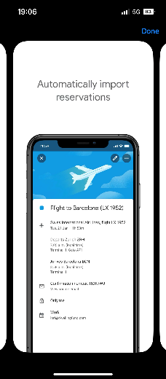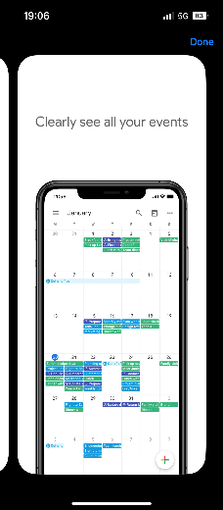

Google Calendar is a popular productivity tool that is used to manage schedules, appointments, and tasks. It has become one of the most widely used calendar applications worldwide. This part of the literature review will examine the features, functionality, and user experience of the Google Calendar app and analyse the research studies conducted on its usage.

Google Calendar provides users with several features that make scheduling and managing events easy (Rampton, 2023). The app allows users to create events, invite attendees, set reminders, and add notes to events. The app can also be synced with other Google services such as Gmail, Google Drive, and Google Meet. This integration enables users to view important emails, files, and video conferencing links related to a particular event.

The app also allows for users to import external calendars into their Google Calendar. It can also do the reverse and allow for users to export their Google Calendar to other platforms. This is a great feature for students as it allows for students to import other external personal calendars including their university timetables with live updates (via sync), allowing for users to be able to have all events that they need to attend in the same place without having to constantly switch between different applications.

The app also provides users with several customization options such as adding colours to events, creating different calendars for different purposes, and setting up recurring events. Google Calendar is available on multiple platforms such as desktop, mobile, and web, making it accessible to users on various devices.

An article by Tech Radar, (2022) investigated effectiveness and functionality of the calendar and deemed it to be great however it came with minor setbacks. The calendar has few advanced features, meaning compared to other competitors like Todoist and ClickUp, it’s not as advanced and simplistic in some aspects. This adds to Tech Radars second point being that the Calendar has too much of a simplistic design, making the view options (weekly view) look messy when multiple calendars are in action. This is not the case with competitors like Microsoft Outlook Calendar as the design allows for better layout when a user has multiple calendars synced.

In conclusion, Google Calendar is a highly functional and easy-to-use app that enables users to manage their schedules efficiently. The app's features such as synchronization with other Google services, customization options, and the ability to create recurring events have been highly appreciated by users. Research studies have also found that the app has a positive impact on work productivity. As a result, Google Calendar is widely used by individuals and organizations worldwide as a tool for managing schedules and improving productivity.

#### Time Tracking Software: Focus keeper

Figure 4 – Focus Keeper User Interface (IOS)

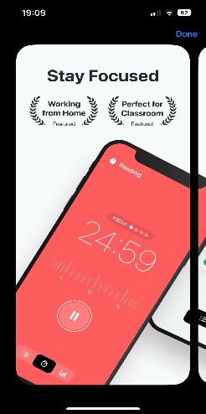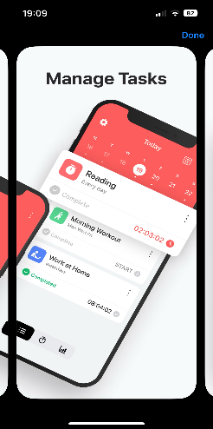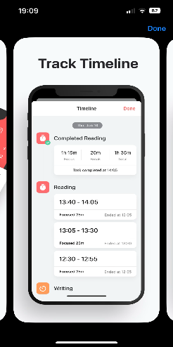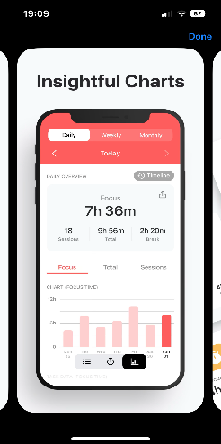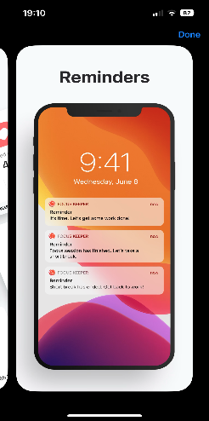

The Focus Keeper app is a mobile application designed to help users increase productivity and manage time more effectively using the Pomodoro technique. The app has gained popularity as a tool for reducing distractions and increasing focus during work or study sessions. The app is available for free on iOS for the basic package but costs $1.99 for the pro version for a year’s subscription. It is designed to help users overcome procrastination and improve their focus by working in 25-minute intervals with 5-minute breaks in between. The app offers customizable settings and a ticking clock to help users stay on task, and the pro version is currently available for free and ad-free (Focus Keeper Pro review: An app that stops your mind from wandering while working on important tasks [Tech and Gadgets] - ProQuest, 2019).

As mentioned previously, the app uses the Pomodoro technique. The Pomodoro technique is a time management method developed by Francesco Cirillo in the 1980s to help him focus on his studies. It involves using a timer to work in 25-minute intervals, followed by a five-minute break and a longer break after every four intervals. The method also includes rules for getting the most out of each interval, such as breaking down complex projects and avoiding interruptions. The technique's core is simplicity and encourages users to track their progress and reflect on ways to avoid interruptions in future sessions. The remaining time after completing a task can be used for overlearning or improving skills. (Todoist, 2015)

However, there are also limitations to the use of Focus Keeper and the Pomodoro technique. An article published by Paloma Torres (2021) goes into detail as to why the technique may not be suitable for some people. Paloma describes her issue with the technique being that the 25-minute intervals are too restrictive. The alarm every 25 mins for the 5-minute breaks tend to disrupt her flow of work and that not all tasks will take the fixed 25 minute amount of time. Also, they explained that the 5 minute breaks are too short leading to these breaks spent unproductively and tends to make her lose track of time. From this we can infer that the Pomodoro technique although helpful for some, isn’t a great solution for all learners and therefore shouldn’t be a default/ only method to structure study time.

Overall, the Focus Keeper app has shown promise as a tool for improving productivity and time management skills, particularly among students and individuals with chronic conditions. However, further research is needed to fully understand the effectiveness of the Pomodoro technique and apps like Focus Keeper in different contexts and for different populations as it may not be suitable for all that study.

#### Time Tracking Software: Flora

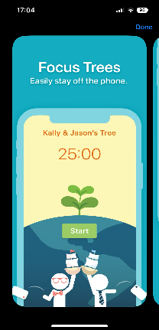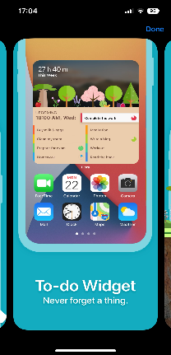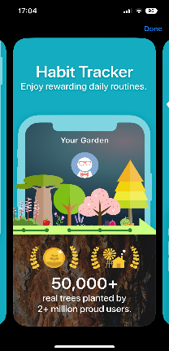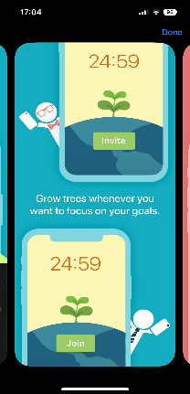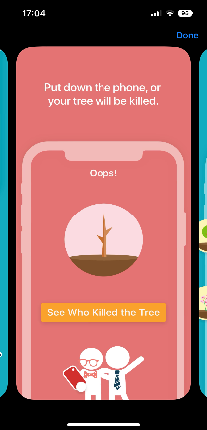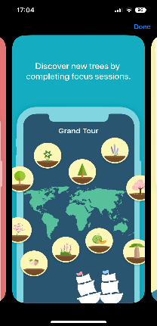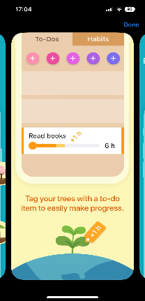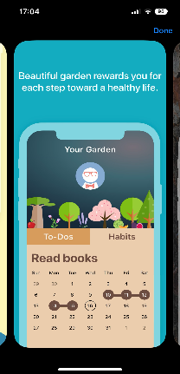

Figure – Flora App User Interface (IOS)

The Flora app is a productivity app that helps users stay focused and manage their time effectively. It is designed to help users stay productive by encouraging them to stay focused on their tasks, avoid distractions and procrastination, and work towards their goals. What makes Flora different is the collaboration it has with Trees.org to better the environment (Trees for the Future, 2022). The collaboration allows for users to help the environment by Trees.org offering a real tree planting service, and people living in Africa while staying focused. This is a great feature and UPS (unique selling point) for the app as it differs from other focus apps (like Focus Keeper) by simultaneously encouraging better studying and focusing habits as well as bettering the planet’s environment.

One of the key features of the Flora app is its focus timer, which allows users to set a specific amount of time for focused work and helps them stay on track with their tasks by providing notifications and reminders (AppFinca Inc, 2023). Users can also set goals and track their progress over time, which can help them stay motivated and focused. Moreover, a great and important feature of the Flora app is its integration with other productivity tools, such as Google Calendar, Trello, and Evernote. This allows users to easily manage their tasks and deadlines across multiple platforms and ensures that they stay organized and on top of their work. In addition, the Flora app also offers social features, such as the ability to join or create groups with friends and colleagues and share progress and achievements with others. This can help users stay accountable and provide motivation and support to each other.

Overall, the Flora app is a useful tool for anyone looking to improve their productivity and manage their time more effectively as well as support the environment as well as the health and wellbeing of others. Its focus on encouraging users to stay focused and avoid distractions is particularly helpful, and its integration with other productivity tools makes it a versatile and powerful app.

### Conclusion:

In conclusion, technology plays a crucial role in assisting university students in managing their time effectively. Time management applications, online learning platforms, electronic calendars, and time tracking software are some of the tools that can be used to improve students' time management skills. While technology can be a useful tool in managing time, it is essential for students to develop good time management habits and use technology effectively. with proper and efficient use of both, students can maximise their individual academic success. However, from my research a found that although there was a lot of information about the tools that I researched, there weren’t many studies of how these specific tools and tools in general could be used and optimised for student success specifically and not just users in general. Users of these tools aren’t just university students and are catered to individuals, businesses, and other types of users. Future research should be conducted to cater to this to find ways to better productivity apps to further benefit students.

# **New Ideas**

## Introduction

In today's fast-paced world, managing time effectively has become increasingly important, especially for university students. With busy schedules, multiple deadlines, and an overwhelming amount of coursework, it can be challenging to stay on top of everything. Fortunately, technology can provide solutions to help students manage their time more effectively. This section will explore innovative ideas and software that can assist university students in organizing their schedules, tracking their progress, and optimizing their study habits. By harnessing the power of technology, students can achieve their academic goals while maintaining a healthy work-life balance.

## Overview of current Challenges

### Procrastination

Procrastination is defined as a behavioural trait or attitude that reflects an indecisive state with a lack of will power and energy to complete a task. When students give in to this tendency, they are unable to accomplish the necessary work at the appropriate time, often postponing it to a later date(Hussain and Sultan, 2010). More specifically, there are two types of procrastination: Decisional and Academic (Hen and Goroshit, 2018). Under stressful circumstances, decisional procrastination is a persistent cognitive form of procrastination that denotes a stable individual difference factor involving delays in decision-making(Ferrari, 2022). This can lead to delays in making important decisions, which can result in missed opportunities or negative consequences(Hen and Goroshit, 2018). Whereas academic procrastination refers to the act of postponing the initiation of a task until the individual feels emotional discomfort due to not having started the activity earlier, even though they still intend to complete it (Tan et al., 2008). This can lead to delayed completion of assignments and preparation for exams which can result in lower grades and academic performance. Ultimately, both types affect students and may result in academic failure and emotional distress and may also extend to their personality traits and learning outcomes.

Moreover, procrastination may appear in students due to various reasons such as fear of criticism, lack of motivation, social and family problems, and academic stress (Ghaffari et al., 2021). Additionally, fatigue and preference to indulge in other activities and hobbies are factors of procrastination in students. All these factors can negatively impact students, further distracting them or making them feel as though they are physically unable to do their work on time or at all. Finding a coping mechanism is crucial to prevent continuous procrastination which therefore has a negative impact on all aspects of a student’s life, personal and academic.

### Balancing work and study

Currently, a significant number of students are required to work one or multiple jobs to cover their university expenses while trying to manage academic requirements and obligations (Jogaratnam and Buchanan, 2004). Although in the past the average student that worked did so to pay for tuition fees, due to skyrocketing costs, current wages come nowhere near to covering all these expenses therefore leaving many students with having to pick up part-time jobs despite not necessarily wanting to (Carnevale, n.d.). As a result, balancing work and study can be challenging, and students may find it difficult to allocate time to both activities.

Interestingly, students that Work part-time for 10-19 hours per week while being a full-time student can lead to greater time spent studying and better overall results. However, students who work fewer or more than 10-19 hours per week do not gain the same benefits, but their GPAs are not negatively affected. However, students that work 10+ hours per week should be aware of potential costs such as increased stress and reduced socializing, as well as other factors that were not assessed in the study (Dundes, 2020). Therefore, finding a balance between the hours that students work and education is crucial for the performance of students.

### Avoiding distractions

Social media usage can have both positive and negative effects on students. On the positive side, social media can provide a platform for peer support and facilitate learning through collaborative opportunities (Ebscohost.com, 2020). Social media can also reduce stress during exams and provide an easy access tool for academic resources.

However, social media can also have negative effects on students. Social media use has been associated with negative body image, fear of missing out, and poor sleep hygiene. Different social media platforms have different effects on stress levels, with Instagram being associated with the most elevated stress levels. Social media use can also lead to privacy concerns and distraction from academic work (Nema P et al., 2022).

Therefore, it is important for students to be aware of the potential negative effects of social media use and to practice responsible usage. This includes setting boundaries for social media use, such as limiting time spent on social media and avoiding late-night scrolling.

### Conclusions

In conclusion, managing time effectively is crucial for university students to stay on top of their coursework and maintain a healthy work-life balance. Procrastination, balancing work, and study, avoiding distractions, and staying on track with assignments and tasks are some of the major challenges that students face. Fortunately, technology can provide innovative solutions to help students overcome these challenges. By utilizing software and tools that assist with organizing schedules, tracking progress, and optimizing study habits, students can achieve their academic goals and avoid the negative consequences of poor time management. It is essential for students to be aware of these challenges and practice responsible usage of technology to ensure academic success and overall well-being.

## Innovative Solutions

From the research that I have conducted, I have concluded that a multi functioning planner for students would be the best solution. This planner will be called UniLife, I decided on this name as it represents the planners aim to help students with both their university life schedule and their personal life schedule. The main functions will allow the user to structure their schedule on a planner and track their important deadlines for their modules. The planner should include the following main features to help students to better manage their time:

* **Deadlines and important dates functionality**: the student will be able to store their deadlines and important dates (not just academic but personal) into the planner and the planner will provide notifications when the deadlines are approaching as a reminder.
* **Timer functionality:** like the pomodoro technique however the user can change the time periods for studying and resting by adjusting it to their own time frames.
* **Student Dashboard:** the planner should have a student dashboard where the user can monitor and track their academic progress. This will include the students grades and results, upcoming deadlines and important dates etc.
* **Calendar:** this calendar will be able to import and sync external calendars and timetables.
* **Notification features:** depending on what the student feels is necessary; the student will be able to enable different notifications as reminders.
* **Module and course information database:** the student will be able to store all information about their course inside the app in an organised layout.
* **Positive pop-up messages:** random inspirational quotes and messages to be relayed to the user to encourage a positive mindset and overall positivity.

#### List of All other Requirements:

* **Android application:** the app should be compatible with all android OS devices.
* **User authentication:** The app should provide user authentication functionality to ensure secure access to the user's data.
* **Notification system:** The app should have a notification system to alert users about upcoming deadlines and events.
* **User Interface:** the app should have an easy-to-use interface that allows users to add, edit, and view events.
* **University timetable sync:** The app should be able to synchronize events with other calendars such as their university course timetable.
* **Accessibility:** The app should be designed to be accessible to all users, including those with disabilities. This may include features like voice commands, large text options, and screen reader support.
* **Event Management:** The app should be able to add, delete, and edit events.
* **Customisation for users:** The app should allow users to customize the interface and set preferences to meet their individual needs.

## Advantages and Limitations

My application ‘UniLife’ has several advantages that set it apart from other schedule/planner applications:

**Focused on Students:** Compared to other mobile app planners, my app will be specifically designed to focus on students’ schedules. this will be achieved by having features that store the users course information. This means that students will be able to use the planner as both a personal planner and a university schedule planner.

**Simple design:** one of the features my planner will have is a simple UI design. I wanted to make sure that the app is easy to use and simple to navigate so that it is accessible for any student. Although most students are of a young demographic, there are university students of all ages therefore, I want to make sure that students of all ages can navigate my system easily no matter the level of tech skills the person has.

**Incorporated ‘focus keeper’ function:** from the review of existing solutions, I concluded as well as a planner, students benefit from a system which helps them keep track of study time and structure it well. Unlike the focus Keeper app however, my system will be able to change how long to set the timer for and how long to set break intervals. This will be better as it allows the user to adapt how long they want their study intervals to be depending on the type of work that they are doing and what works best for them.

However, there will be some limitations for my application:

**No external application integration:** My application won’t be able to import other applications like Microsoft OneDrive, to work in sync with each other. This will limit the app’s flexibility with other apps that users may use and possibly limit the apps overall usefulness.

**Reliant on user input:** For the app to be effective, it will depend on the user’s ability to input accurate and relevant data. If the user doesn’t use all the features and fails to input the relevant information like deadlines, then the app’s usefulness may be limited.

**Privacy:** The app will ask for personal information (for example the student’s name and university email address), this may raise privacy concerns for certain uses as their personal information could be at risk to being breached.

**Limited device compatibility:** Due to my app prototype being built in android studio, the app will be limited to android users only, excluding a large demographic of IOS users and users of other mobile operating systems. However, for further development, the app will be expanded to IOS developers.

## User Interface Design

Figure – Simple UI design for UniLife App

Above is a simple UI design that I have created for my application prototype showing the main pages included to meet my app requirements. The app will have 6 main pages: Course Details, Personal Profile, Calendar, Login, Sign Up and Focus Tracker. The course details page is where the user will be able to add details and respective modules about their course. The page will also have a section where the user will be able to add deadlines for individual modules which will then be exported to the calendar where they can be viewed. This page is crucial to the aim of my application as it will be a tool to organise the user’s/student’s modules in order to track future deadlines. This therefore will help the user increase their overall organisation to improve time management.

The personal profile will be where the user can update and edit their personal details. The page will include information such as their name and email address etc. As well as for the user’s benefit this is important in order to track how many users have accounts and are actively using it. This will be disclaimed in the terms and conditions of the application once published officially as an android application. This is also where the student’s personal dashboard will be included in future developments, but not in the prototype version.

The calendar page is crucial for the operation of the whole app. This is where the student will be able to sync other calendars into the app and add upcoming events to their schedule in order to track and organise their study as well as personal time better. The calendar will be able to give live updates in case the user’s external timetables/calendars change. Also, the calendar will be able to use information from the course details page (such as the module deadlines) and import that information so that it can be visualised in the calendar.

Furthermore, the app will have both sign up and login pages for the user to log in and create an account once the app has been downloaded. These pages are crucial for further development of the app and not so much the prototype. In an effort to continuously improve the app and observe what is working well, the users will need personal accounts in order to track and review their data and therefore will be used to improve the customer’s overall experience.

Finally, the Focus Tracker page will be a tool to help students manage their time with studying specifically. This tool will be a timer tool which will set time frames for active studying and taking breaks. ‘set focus session’ will be a timer function which can allow the student to set any period of time to study for. ‘set break session’ will be the timer function which will be triggered once the study session is over. The student will also be able to set how many times they would like to repeat this for.

# **Implementation**

## Technical Specification for UniLife

The technical specification will overview what the finished application will include in terms of functionality and achieve unlike the prototype version that I will be creating.

### Overview

The student planner ‘UniLife’ is a digital tool designed to help students manage their academic schedules, assignments, and deadlines. As well as academic responsibilities the planner will be a tool to manage their personal and work lifestyles. The planner will be accessible through a mobile app and will be compatible with multiple platforms.

### Features

**The student planner will have the following features:**

Personalized Dashboard: Students will be able to see an overview of their upcoming assignments, deadlines, and schedule on their personalized dashboard.

Schedule Management: Students will be able to add, view, and edit their schedules for each day, week, and month.

Task Management: Students will be able to add, view, and edit their tasks and deadlines for each module and assignments.

Grade Tracking: Students will be able to track their grades for each module and assignments.

Notification System: The planner will have a notification system to remind students of upcoming assignments, deadlines, and events. The notifications will have an optional function where the student can opt in for daily motivation quotes and messages as pop ups.

### What to Avoid

* The planner should avoid collecting unnecessary personal information from users. the only information necessary will be needed to monitor the usefulness of the app and improve it accordingly.
* The planner should avoid using language that is exclusive or insensitive to certain groups of people.
* The planner should also avoid having an interface which is too complicated to navigate or too overcrowded with features and functionalities; all features should have a specific purpose.

### Technical Skills Requirements

* Knowledge of mobile app development (Android Studio, Java, Xcode (for IOS))
* Knowledge of database management (SQLite)
* Experience with agile development methodologies
* Familiar with cloud hosting and deployment methods

### Resources

* A development team consisting of mobile app developers, and database administrators.
* A project manager to oversee the development process and ensure timely delivery.
* A server to host the mobile application.
* A database to store user information and planner/calendar data.

### Special Techniques

For further developments and updates of the app, the planner will use machine learning algorithms to suggest study times and strategies based on a student's past performance.

### Costing

The costing of the project will depend on various factors such as the size of the development team, the project duration, the complexity of the features, and the hosting and maintenance costs. For example: the app platform. For android there is a one-time fee of $25 that developers need to pay, whereas for IOS, there is a yearly fee of $99.

## Diagrams

## Tools and Techniques

Research Tools: NTU OneSearch, Google Scholar

Both NTU OneSearch and Google Scholar are great tools for research. They both allow for comprehensive coverage of a vast collection of scholarly literature including books, papers and articles. Although google scholar has a wider range of resources and materials, OneSearch allows for access to a lot of the materials that are private. Through NTU OneSearch, restricted articles that would need a subscription can be accessed.

Programming Languages: Java, XML, SQL

For programming languages Java is the best choice as I already have familiarity with the language and has a lot of flexibility. The language allows for cross-platform compatibility meaning that the code can be run on both Android and IOS (for future developments) without having to change the code significantly. It also is a versatile language which has a large variety of libraries and frameworks which will be useful when creating the type of application that I want to develop. SQL will be needed for database management and is specifically good for relational databases (which my application will be using). SQL is best for my application as it is easy implement and has good features like efficient data security and compatible with most relational database systems.

IDE/Development Platforms: SQLite, Android Studio

For my IDE, Android Studio was the best option as I have familiarity with the tool already. Moreover, to create android applications, it is one of the best tools as the user interface makes it easy to use and the application comes with a vast number of libraries and resources which will be important for the development of my application. For database management, I will be using SQLite as it is an open-source tool and easy to use in conjunction with Android Studio. This will be a great option as it has fast performance and low memory footprint, meaning that I won’t slow down the overall performance of my whole application.

Design Tools/Platforms: Teamgantt.com, draw.io

For the planning part of my project, I will use Teamgantt.com to organise and structure how long to spend on each task to produce my prototype deliverable. The tool allows for Gantt chart creation and will allow for me to construct and track deliverables to complete the development of my project. For the diagrams for the design of my application, I will use draw.io. Draw.io is a great tool as allows for easy creation of specific diagrams like flow charts and entity-relationship diagrams which are used to help visualise the structure and design of my application.

## Planning

The purpose of this planning section is to outline the steps I took to develop the student planner app ‘UniLife’. I will discuss the steps that will be taken to mitigate potential problems and create a test plan for my prototype.

### Mitigation Plan

|  |  |  |  |  |
| --- | --- | --- | --- | --- |
| **RISKS** | **PROBABLITY (1-5)** | **IMPACT** | **SEVERITY (1-5)** | **MITIGATION PLAN** |
| Virtual device emulator stops working | 3 | It will not be possible to observe the application while it is under development. | 4 | Follow the necessary steps to troubleshoot this problem to fix it |
| Virtual device or physical device cannot connect to android studio | 1 | Unable to make further progress due to not being able to see application in the works | 5 | Use the help guide to troubleshoot and fix the problem |
| Unable to connect external timetables to application | 3 | Will not be able to complete one of crucial tasks for application to meet objectives | 4 | Prepare a backup function which allows the user to input their timetable in manually which will automatically adjust for the rest of the year |
| Android software won’t run application | 1 | Students will be unable to test the application prototype. | 5 | Allow for time to design a presentation which explains the application in detail and present to students as a substitution |
| Android Studio stops working | 1 | The development of the application must be put on hold. | 5 | Have a backup integrated development environment that I can continue to develop my application on |
| Loss of source code | 1 | Failing to meet key objectives for the project. | 5 | Make sure source code is backed up on multiple devices and drives. Save a zip file with source code, every time a deliverable is completed. |
| Loss of documentation | 1 | There will be little to no evidence of whether my project was completed | 5 | Save report document on multiple devices and cloud storage. |
| Not meeting personal and Gantt chart deadlines due to personal problems | 4 | Time management will be affected and may prevent objectives being completed. | 3 | Try to complete tasks earlier than deadlines to allow for extra time for other tasks in case of an emergency. |
| Not being able to conduct interviews due to no students able to take part | 2 | Unable to test whether my application is suited to my target audience | 4 | Plan (well in advance) and book timed slots with students so that they can take part in research. |
| Project is too complicated to complete a sufficient app prototype | 2 | The main objectives of the project will not be achieved. | 5 | Break down the tasks and deliverables even further to simplify the problem even more to complete it. |
| Sufficient prototype not completed due to limited time to build application | 4 | The main objectives of the project will not be achieved. | 4 | Stick to Gantt chart deadlines to allow for time to complete everything on time |
| Supervisor is not available for guidance | 2 | May struggle to complete certain objectives timely or at all | 3 | Have a weekly meeting scheduled with supervisor to allow constant feedback and support |
| Poor time management | 3 | Meeting all tasks in time to fulfil the main objectives may be difficult to achieve. | 4 | Stay motivated by taking care of myself mentally and physically. |

## Unit Testing

|  |  |  |  |  |  |  |
| --- | --- | --- | --- | --- | --- | --- |
| Test ID | Test Scenario | Test Plan | Expected Results | Actual Result | Passed/Failed | Retest |
| **Course Details** |  |  |  |  |  |  |
| 01 | User can input year of study in date format | App will run and the user will enter a date into the text box | When box is clicked, the date format appears for user to select | No date format is shown but text box can be written into | Failed | Yes |
| 02 | User can input course name | App will run and when box is clicked user can enter details | User input is available | The user was able to enter input | Passed | N/A |
| 03 | Add button adds modules | when the button is pressed, user is directed to another page | User is directed to another page | User was directed to another page | Passed | N/A |
| 04 | Drop down menu adds deadline type | When clicked the user can selected deadline types | Dropdown menu appears with two selections | User adds deadline type when dropdown menu is selected | Passed | N/A |
| 05 | Deadline can add via ‘Add Deadline’ button | When clicked user can add as many deadlines to a module | Button adds new entries for user input | User could add new entries | Passed | N/A |
| 06 | If deadline type isn’t selected then error is shown | User presses add deadline without selecting type | Error is shown on attempted | Pop up error message is returned to the user | Passed | N/A |
| **Personal Profile** |  |  |  |  |  |  |
| 07 | Add profile picture to personal Profile | When profile picture icon is selected, user can add image | User is directed to photo folders | User is directed to photo folders to selected from phone | Passed | N/A |
| 08 | User can edit name, course name, email and year of study | User presses data entry boxes and can edit them | Text box can be written into | User can change details in text box | Passed | N/A |
| **Calendar** |  |  |  |  |  |  |
| 09 | When arrows selected, calendar can switch between months | Users presses arrow navigation on calendar page | Month is changed to previous/next month when arrow selected | Month changes | Passed | N/A |
| 10 | Calendar shows module deadlines | User selects data with an existing entry | Module deadlines are shown under specific dates | Module Deadlines are shown | Passed | N/A |
| **Login** |  |  |  |  |  |  |
| 11 | user can login with email and password created on sign up | User enter username and password and program successfully signs in | Program allows user to log in | Login Successful | Passed | N/A |
| 12 | When incorrect details are entered an error is displayed and user can’t log in | User enters incorrect login details and error should occur | Error pop up when user tries to login | Error returned to the user | Passed | N/A |
| **Sign Up** |  |  |  |  |  |  |
| 13 | User enters first name, last name, course, email address, password and year of study to create an account | Upon loading app user can create a new account | User can sign up via sign up page | User enters details and signs ups | Passed | N/A |
| 14 | When password is entered, it is hidden for security measures | User types in password and it is in asterisk | Asterisks can be seen when password is typed in | Asterisks can be seen when password is typed in | Passed | N/A |
| **Focus Tracker** |  |  |  |  |  |  |
| 15 | User can set the focus session time frame | User types in time frame for time | User enters time in text box | Data entry is valid | Passed | N/A |
| 16 | User can set the break time frame | User types in time frame for time | User enters time in text box | Data entry is valid | Passed | N/A |
| 17 | User can set the interval for the focus tracker | User types in how many repetitions in box | User enters number in text box | Data entry is valid | Passed | N/A |
| 18 | When focus time is set, start button triggers the session | User presses start button | Focus keeper activates | The timer starts and fucus keeper activates | Passed | N/A |

# **Results**

## Success Criteria

*Objective 1: To investigate the impact of time management on the quality of life of university students.*

Evaluation: The project presented a comprehensive literature review of existing research on time management and its impact on the quality of life of university students. This included the role of technology with time management and exploring the effective time management strategies that students can take. The analysis of the data indicated a strong correlation between effective time management practices and improved quality of life for university students.

*Objective 2: To examine the effectiveness of various time management applications and software tools in facilitating better time management practices among university students.*

Evaluation: The project evaluated a variety of time management applications and software tools that are available to university students including Trello, Evernote, Google Calendar, Focus Keeper and Flora. Each of the applications addressed different methods of organising time management for students. The project provided a detailed analysis of the features and benefits of each tool based on the needs of university students.

*Objective 3: To identify the key factors involved in effective time management for university students.*

Evaluation: The project also identified several key factors that are essential for effective time management among university students. These factors include balancing work and study, avoiding distractions, and ways to avoid and prevent procrastination. The project also highlighted the importance using appropriate tools to help manage time effectively for students.

*Objective 4: To create a prototype solution of an app to help students with their time management.*

Evaluation: The project developed a prototype of an app that can help university students manage their time more effectively. The app includes features such as a feature similar to the Focus Keeper app, a personal profile where the student can manage their information, a calendar where students can manage their schedule and a feature that helps students track their course deadlines. The project also completed unit testing to make sure that the prototype ran effectively.

*Objective 5: To provide recommendations for university students on how to optimize their time management skills using technology.*

Evaluation: The project provided a range of recommendations for university students on how to optimize their time management skills using technology. These recommendations included using complex planners with features targeted to students and utilizing productivity tools like Pomodoro timers (i.e., Focus Keeper and Flora). The project also emphasized the importance of balancing technology use making sure to manage time on other software such as social media.

*Objective 6: To evaluate the potential impact of improved time management skills on academic performance and personal outcomes for university students.*

Evaluation: The project identified how improved time management skills effect students positively and therefore improve academic performance. However, the project didn’t evaluate the prototype against students to find out whether it was a solution and a success for improved time management skills.

In Summary, the project demonstrated a thorough understanding of the importance of time management skills for university students and provided a range of practical recommendations and solutions to help them optimize their time management practices. The project was well-researched, innovative, and impactful, and it has the potential to benefit a wide range of university students. However, for future development the project should be evaluated against a test group of students in order to see how it impacts real life students and their performance.

## Technique

### Testing:

To test the UniLife app, unit testing was conducted to ensure that each module of the app was functioning correctly. Features and functionalities of the app were identified and tested against the expected outcomes to make sure that everything was working efficiently.

Outcomes:

Based on the testing results, it was concluded that UniLife app was successful in meeting its objectives. During the unit testing, all the initial requirements for the prototype that were prefaced were met. However, more testing was needed to assess whether the solution increases productivity for students in real life.

Future Testing:

In the future, there are plans to conduct further testing on the app's performance, including stress testing and load testing. in order to evaluate the stability and error handling capabilities of the system stress testing is needed and to evaluate the system under realistic expected levels of load. Tools like Junit Testing Framework and Firebase will be used to carry out integration testing, user acceptance testing, usability testing and security testing. Also, planning will be administered to gather feedback from a large group of university students to evaluate the app's effectiveness in helping them manage their time more effectively.

### Testing Plan for Future Developments

In order to make sure the project meets all the requirements and is suitable for the target audience, students, several different kinds of testing can be conducted throughout the development and after to make sure it is an efficient system. The following discusses these methods in more detail.

Unit and Integration Testing:

Just like the testing done for the prototype, unit testing will be conducted to ensure that each module of the app is functioning correctly. However, alternatively, JUnit testing framework will be used to test individual classes and methods as it is more effective and more reliable than the method that was implemented for the prototype. After completing unit testing, integration testing will be performed to verify that all modules of the app are working together as expected. Another tool such as Appium will be used to automate the integration testing process.

User Acceptance and Usability Testing:

User acceptance and usability testing will be executed to ensure that the app meets the requirements and expectations of our target audience, university students including the evaluation of the app’s user interface and user experience. To do this a group of 50 university students (on a range of different courses) will be recruited to participate in the process. During this testing, the usability, functionality, performance, UI and UX of the app will be evaluated. The testing will be done both on physical devices and emulators.

Performance Testing:

An important factor of a great application solution is the performance. To make sure the app runs smoothly, performance will be measured by recording the app’s loading time, response time and data transfer speed. This can be conducted by using tools like Firebase performance Monitoring to see how the app copes with performance under heavy usage. This is important as once the app is published; the app will be open to use by all users and therefore will need to be able to handle multiple users using the system consecutively.

Security Testing:

As the application stores sensitive and private information, it is important to make sure than information is protected from data breaches. As well as encrypting this information, security testing will be conducted to identify any vulnerabilities in the app’s security. To do this, tools like Burp Suite can be used to identify threats.

## Analysis

The user interface design of the project was well executed, with a clear layout and easy-to-use functionality. Users are able to navigate the application quickly and easily, and the design was visually appealing. However, the design does come across as too simplified therefore, more detail and more appealing UI design should be implemented in future developments. Despite this, the user interface design was a success as it met the requirements.

Furthermore, the functionality of the project was somewhat mixed. While the core features of the application, such as personal profile and focus tracker were well implemented and functional, there were some issues with more advanced features such as the calendar with integrating sync capabilities with other external calendars. Also, one of the requirements was to have positive pop up messages to encourage students, however this wasn’t implemented due to time constraints. These issues detracted somewhat from the overall functionality of the application prototype.

In addition, the performance of the project was also mixed. While the application was generally fast and responsive, there were some issues with data synchronization and storage (due to the device that the application was developed on) that caused slowdowns and other issues. These performance issues were not severe enough to render the application unusable, but they did detract somewhat from the user experience. In future developments, these issues can be mitigated by developing the project on a more powerful machine.

The testing process for the student planner project was generally well executed, with a thorough unit testing plan and effective debugging tools in place. However, there were some issues with the testing process that resulted in some bugs and issues being missed during development. This highlights the need for more rigorous and comprehensive testing procedures in future projects.

In conclusion, the project was a success in some areas and less successful in others. Analysis and investigation of the problem was executed well however, the conduction of implementation of the prototype could’ve been executed better. The user interface design was well executed and the core functionality of the application was strong. However, issues with more advanced features, performance, and testing highlight areas for improvement in future projects. If the project were to be done again, it would be done differently to address these issues and improve the overall quality of the application.

# **Appendix**

## Gantt Chart

Figure 6 – Gantt Chart for Report and App Development



7

8

15

22

29

5

12

19

26

5

12

19

26

2

9

16

23

/

1

/

23

2

3

/

2

3

23

4

/

**Gantt chart**

**h**

**0**

**%**

**0**

**Report**

**h**

**0**

**0**

**%**

Introduction Edit

0

%

0

**Context**

**h**

**0**

**%**

**0**

Start of Literature Review

0

0

%

Research of Time Management

0

%

0

Research Technology and Time Man...

0

%

0

Final Conclusions

0

%

0

Context Section Completed

0

%

0

**New Ideas**

**0**

**h**

**0**

**%**

Research of Overview of Current Chal...

0

0

%

Innovative Solutions

0

0

%

Discussion of Advantages and Disad...

0

0

%

User Interface initial Design

0

0

%

New Ideas Section Complete

0

0

%

**Implementation**

**0**

**h**

**0**

**%**

Technical Spec creation

0

%

0

Design Stage: Diagrams

0

0

%

Tools and Techniques

0

0

%

Planning: Mitigation Plan

0

0

%

Development: Sign Up and Login Pa...

0

0

%

Development: Calendar Page

0

%

0

Development: Course Details Page

0

%

0

Development: Personal Profile Page

0

%

0

Unit Testing

0

0

%

Implementation Complete

0

0

%

**Results**

**0**

**h**

**0**

**%**

Create Success criteria future imple...

0

%

0

Future Testing Plan

0

%

0

Technique Section

0

0

%

Analysis Section

0

%

0

Abstract

0

%

0

Sort References and Appendix

0

%

0

Report Complete

0

%

0



|  |  |  |
| --- | --- | --- |
| A screenshot of a calculator  Description automatically generated Testing Images Figure – Test 01 | A screenshot of a phone  Description automatically generated with medium confidence  Figure – Test 02 | A picture containing text, screenshot, font, logo  Description automatically generated  Figure – Test 03 |
| A picture containing text, screenshot, font, electric blue  Description automatically generated  Figure - Test 04 | A screenshot of a phone  Description automatically generated with low confidence  Figure - Test 06 | A person in a suit and tie  Description automatically generated with medium confidence  Figure - Test 07  A baby in a circle  Description automatically generated with low confidence  Figure - Test 07 |
| A screenshot of a phone  Description automatically generated with medium confidence  Figure - Test 08 | A screenshot of a calendar  Description automatically generated  Figure - Test 09 | A screenshot of a calendar  Description automatically generated  Figure – Test 10 |
| A screenshot of a login screen  Description automatically generated with medium confidence  Figure - Test 11 | A black rectangle with white text  Description automatically generated with medium confidence  Figure - Test 13 | A screenshot of a login screen  Description automatically generated with medium confidence  Figure - Test 14 |
| A screenshot of a cellphone  Description automatically generated with medium confidence  Figure - Test 15 - 18 |  |  |

# **References**

Alhasani, M., Alkhawaji, A. and Orji, R. (2021). Mental Health and Time Management Behavior among Students During COVID-19 Pandemic: Towards Persuasive Technology Design. [online] doi:https://doi.org/10.1101/2021.10.01.21264409.

AppFinca Inc (2023). *Flora - Green Focus*. [online] Flora. Available at: https://flora.appfinca.com/en/.

Attia, N., Baig, L., Marzouk, Y.I. and Khan, A. (2017). The potential effect of technology and distractions on undergraduate students’ concentration. *Pakistan Journal of Medical Sciences*, [online] 33(4). doi:https://doi.org/10.12669/pjms.334.12560.

‌ Carnevale, A. (n.d.). *Balancing Work and Learning IMPLICATIONS FOR LOW-INCOME STUDENTS*. [online] Available at: https://repository.library.georgetown.edu/bitstream/handle/10822/1052638/Low-Income-Working-Learners-FR.pdf?sequence=1&isAllowed=y.

COVID-19 Transitions to Online Formats and Pre-Pandemic Foundations for Student Success: Time Management and Lifestyle Variables - ProQuest. (2020). *Proquest.com*. [online] doi:https://doi.org/%22,.

‌ Disselkamp, L. ed., (2012). *No Boundaries*. [online] Hoboken, NJ, USA: John Wiley & Sons, Inc. doi:https://doi.org/10.1002/9781119203841.

‌ Downing, J.E., Peckham Hardin, K.D., 2001. *Daily Schedules: A Helpful Learning Tool* [online]. *https://journals.sagepub.com/*. Available at: https://journals.sagepub.com/doi/pdf/10.1177/004005990103300310?casa_token=Hgg6ipKxvp4AAAAA:q67deyLnvhys1j3dbIUP6sQQjE_qdpiaZ4PBfUfGin_A35cLy1kZXIrvC-Lox9xWuDpvK9md16-FmQ [Accessed 10 April 2023].

‌Dundes, L. (2020). *Balancing Work and Academics in College: Why Do Students Working 10 to 19 Hours per Week Excel? - Lauren Dundes, Jeff Marx, 2006*. [online] Journal of College Student Retention: Research, Theory & Practice. Available at: <https://journals.sagepub.com/doi/10.2190/7UCU-8F9M-94QG-5WWQ>.

‌Ebscohost.com. (2020). *Social Media Usage among University Students during Exams: Distraction or A...: EBSCOhost*. [online] Available at: https://web.p.ebscohost.com/ehost/pdfviewer/pdfviewer?vid=0&sid=4b1ef2e1-f4a4-45a4-98d0-0bd43fba7c5f%40redis.

‌ Evernote Help & Learning. (2018). *Evernote*. [online] Available at: https://help.evernote.com/hc/en-us/articles/217961187-Evernote-for-Students#:~:text=Whether%20you're%20pursuing%20a,get%2050%25%20off%20Evernote%20Personal.

‌Ferrari, J.R. (2022). *Frequent Behavioral Delay Tendencies By Adults: International Prevalence Rates of Chronic Procrastination - Joseph R. Ferrari, Juan Francisco Díaz-Morales, Jean O’Callaghan, Karem Díaz, Doris Argumedo, 2007*. [online] Journal of Cross-Cultural Psychology. Available at: https://journals.sagepub.com/doi/10.1177/0022022107302314 [Accessed 9 Apr. 2023].

‌ Focus Keeper Pro review: An app that stops your mind from wandering while working on important tasks [Tech and Gadgets] - ProQuest. (2019). *Proquest.com*. [online] doi:https://doi.org/%22,.

‌Gianaros, P.J. (2015). *Brain-Body Pathways Linking Psychological Stress and Physical Health - Peter J. Gianaros, Tor D. Wager, 2015*. [online] Current Directions in Psychological Science. Available at: https://journals.sagepub.com/doi/10.1177/0963721415581476.

‌Ghaffari, F., Mohammadi, S., Arazi, T., Arzani, A. and Rahimaghaee, F. (2021). Shedding light on the causes of academic procrastination among nursing students: A qualitative descriptive study. *Journal of education and health promotion*, [online] 10(1), p.181. doi:https://doi.org/10.4103/jehp.jehp_1103_20.

‌ Hen, M. and Goroshit, M. (2018). The effects of decisional and academic procrastination on students’ feelings toward academic procrastination. *Current Psychology*, [online] 39(2), pp.556–563. doi:https://doi.org/10.1007/s12144-017-9777-3.

‌ Hine, K. (2014). Evernote. *Journal of the Canadian Health Libraries Association / Journal de l’Association des bibliothèques de la santé du Canada*, [online] 35(1), p.41. doi:https://doi.org/10.5596/c14-001.

‌ Hussain, I. and Sultan, S. (2010). Analysis of procrastination among university students. *Procedia - Social and Behavioral Sciences*, [online] 5, pp.1897–1904. doi:https://doi.org/10.1016/j.sbspro.2010.07.385.

International Journal of School & Educational Psychology. (2016). *Effects of stress on students’ physical and mental health and academic success*. [online] Available at: https://www.tandfonline.com/doi/full/10.1080/21683603.2016.1130532?scroll=top&needAccess=true&role=tab.

Internet Archive. (2015). *The Psychology Of Wants Interests And Attitudes : Edward L. Thorndike : Free Download, Borrow, and Streaming : Internet Archive*. [online] Available at: https://archive.org/details/in.ernet.dli.2015.157494/page/n98/mode/1up [Accessed 11 Apr. 2023].

Johnson, MLIS, H.A. (2017). Trello. *Journal of the Medical Library Association*, [online] 105(2). doi:https://doi.org/10.5195/jmla.2016.49.

‌Jogaratnam, G. and Buchanan, P. (2004). Balancing the demands of school and work: stress and employed hospitality students. *International Journal of Contemporary Hospitality Management*, [online] 16(4), pp.237–245. doi:https://doi.org/10.1108/09596110410537397.

Journal of Hospital Librarianship. (2018). *App Review: Trello*. [online] Available at: https://www.tandfonline.com/doi/full/10.1080/15323269.2018.1400840 [Accessed 5 Apr. 2023].

Jstor.org. (2023). *Stresses of Mature Students on JSTOR*. [online] Available at: <https://www.jstor.org/stable/3119788?saml_data=eyJzYW1sVG9rZW4iOiI5MWIzMmM3Yy0yNDU1LTRmMTktOGVhOC0yZDgyZDEwZGM5ZjIiLCJpbnN0aXR1dGlvbklkcyI6WyIxMTgxMTM5Mi0yMThiLTRiMjEtYTgwZS1mOGY2MmQwZjJiZDYiXX0&seq=2>.

Kharb, P. (2013). The Learning Styles and the Preferred Teaching–Learning Strategies of First Year Medical Students. *JOURNAL OF CLINICAL AND DIAGNOSTIC RESEARCH*. [online] doi:https://doi.org/10.7860/jcdr/2013/5809.3090.

‌‌Kornhauser, A.W. (1993). How to Study, 3rd edition. Chicago: University of Chicago Press. Locke, E.A. (1975). A Guide to Effective Study. New York: Springer.

‌ Macan, T.H., Shahani, C., Dipboye, R.L. and Phillips, A.P. (1990). College students’ time management: Correlations with academic performance and stress. *Journal of Educational Psychology*, [online] 82(4), pp.760–768. doi:https://doi.org/10.1037/0022-0663.82.4.760.

Morisano, D., Hirsh, J.B., Peterson, J.B., Pihl, R.O. and Shore, B.M. (2010). Setting, elaborating, and reflecting on personal goals improves academic performance. *Journal of Applied Psychology*, [online] 95(2), pp.255–264. doi:https://doi.org/10.1037/a0018478.

‌ My beef with the Pomodoro Technique - ProQuest. (2021). *Proquest.com*. [online] doi:https://doi.org/%22,.

Nema, P., Srivastava, R., Bhalla, R., Chakarboty, A. (2022). *Impact of social media distraction on student evaluation of teacher effectiveness | Emerald Insight*, [online] 37(2), pp.300–313. doi:https://doi.org/10.1108//IJEM.

‌Pozos-Radillo, B.E., Preciado-Serrano, M. de L., Acosta-Fernández, M., Aguilera-Velasco, M. de los Á. and Delgado-García, D.D. (2014). Academic stress as a predictor of chronic stress in university students. *Psicología Educativa*, [online] 20(1), pp.47–52. doi:https://doi.org/10.1016/j.pse.2014.05.006.

‌ Race, P. (2003). How to Study: Practical Tips for Students. Oxford: John Wiley & Sons.

‌ Rampton, J. (2023). *The Ultimate Guide To Google Calendar*. [online] Calendar. Available at: https://www.calendar.com/google-calendar-guide/#intro.

Roper, A.R. (2007). How students develop online learning skills. EDUCAUSE Quarterly Magazine, 50(1), 62-65.

‌ Sánchez, F., Carvajal, F. and Saggiomo, C. (2015). Autodiálogos y rendimiento académico en estudiantes universitarios. *Anales de Psicología*, [online] 32(1), p.139. doi:https://doi.org/10.6018/analesps.32.1.188441.

Sayles, S. and Shelton, D.P. (2005). *Student success strategies*. [online] ResearchGate. Available at: <https://www.researchgate.net/publication/7500315_Student_success_strategies>.

‌Tan, C.X., Ang, R.P., Klassen, R.M., Yeo, L.S., Wong, I.Y.F., Huan, V.S. and Chong, W.H. (2008). Correlates of Academic Procrastination and Students’ Grade Goals. *Current Psychology*, [online] 27(2), pp.135–144. doi:https://doi.org/10.1007/s12144-008-9028-8.

‌ TechRadar. (2022). *Google Calendar*. [online] Available at: <https://www.techradar.com/reviews/google-calendar>.

‌ Todoist. (2015). *The Pomodoro Technique — Why It Works & How To Do It*. [online] Available at: https://todoist.com/productivity-methods/pomodoro-technique#what-is-the-pomodoro-technique.

‌ Toussaint, L. (2016). *Effects of lifetime stress exposure on mental and physical health in young adulthood: How stress degrades and forgiveness protects health - Loren Toussaint, Grant S Shields, Gabriel Dorn, George M Slavich, 2016*. [online] Journal of Health Psychology. Available at: <https://journals.sagepub.com/doi/abs/10.1177/1359105314544132?journalCode=hpqa>.

‌ Trees for the Future. (2022). *Flora - Trees for the Future*. [online] Available at: <https://trees.org/sponsor/flora/>.

‌ Trello: The best app to have higher productivity in Home Office - ProQuest. (2021). *Proquest.com*. [online] doi:https://doi.org/%22,.